Comprehensive Digital Evidence Acquisition and Command-Line Analysis using FTK Imager
EXPERIMENT NO: 01
DATE:
1. AIM
To perform a complete forensic acquisition and analysis lifecycle by imaging non-volatile storage using AccessData FTK Imager, capturing live volatile memory (RAM) using the WinPmem command-line utility, and analyzing the extracted memory dump using Volatility 3 commands via the PassMark Volatility Workbench.

2. SOFTWARE / TOOLS REQUIRED
- Operating System: Windows OS
- Forensics Tools:
  - AccessData FTK Imager (GUI for non-volatile physical drive imaging)
  - WinPmem (winpmem_mini_x64_rc2.exe) (CLI tool for volatile memory capture)
  - Volatility 3 Framework (vol.exe / PassMark Volatility Workbench V3.0)
- Hardware: Evidence PC/Workstation, Target Storage Drive (hp v221w 16GB USB Device).

3. DESCRIPTION
A thorough digital forensic investigation requires collecting both data at rest and data in motion using strict operational procedures.
- Non-Volatile Memory Acquisition: AccessData FTK Imager creates mathematically verifiable, bit-by-bit physical images of storage devices (saved as Raw/dd) without altering the original evidence.
- Volatile Memory (RAM) Acquisition: Command-line utilities like WinPmem load a specialized kernel driver (pme98A2.tmp) to read physical memory directly. Executing this via CMD writes active processes, network connections, and decrypted keys to a raw dump file (.raw).
- Volatile Memory Analysis (CLI): Volatility 3 is a framework for analyzing RAM dumps. By passing specific parameters and plugins (e.g., -f <image_path> windows.pslist.PsList) into the command line or workbench, investigators can reconstruct the system's live state and identify suspicious processes.

4. PROCEDURE
Acquiring Non-Volatile Memory (Disk Image) using FTK Imager
Step 1: Select the Source Type
Open FTK Imager as an Administrator. Navigate to File > Create Disk Image. In the Select Source dialog, choose Physical Drive.
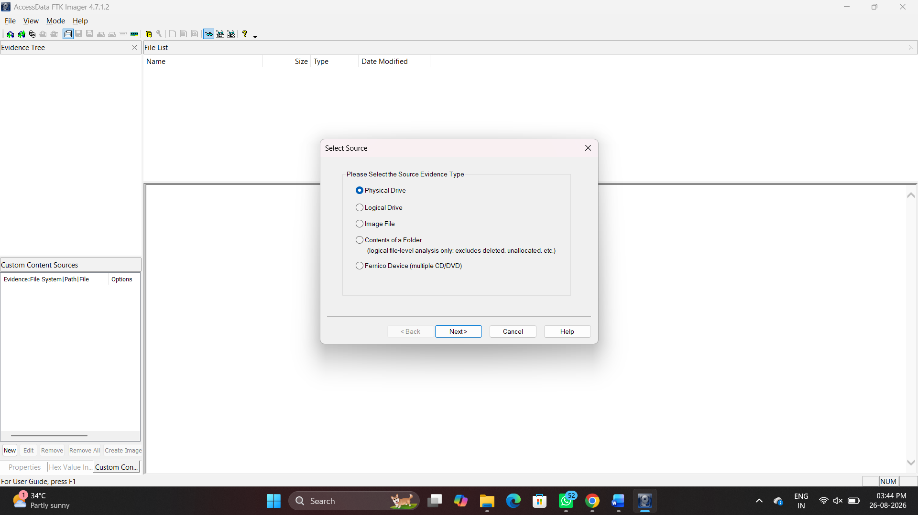
Figure 1: Selecting Physical Drive as the source evidence type

Step 2: Select the Specific Drive
Select the target evidence drive (\\.\PHYSICALDRIVE1 - USB SanDisk 3.2Gen1 USB device[30GB USB]) from the dropdown.
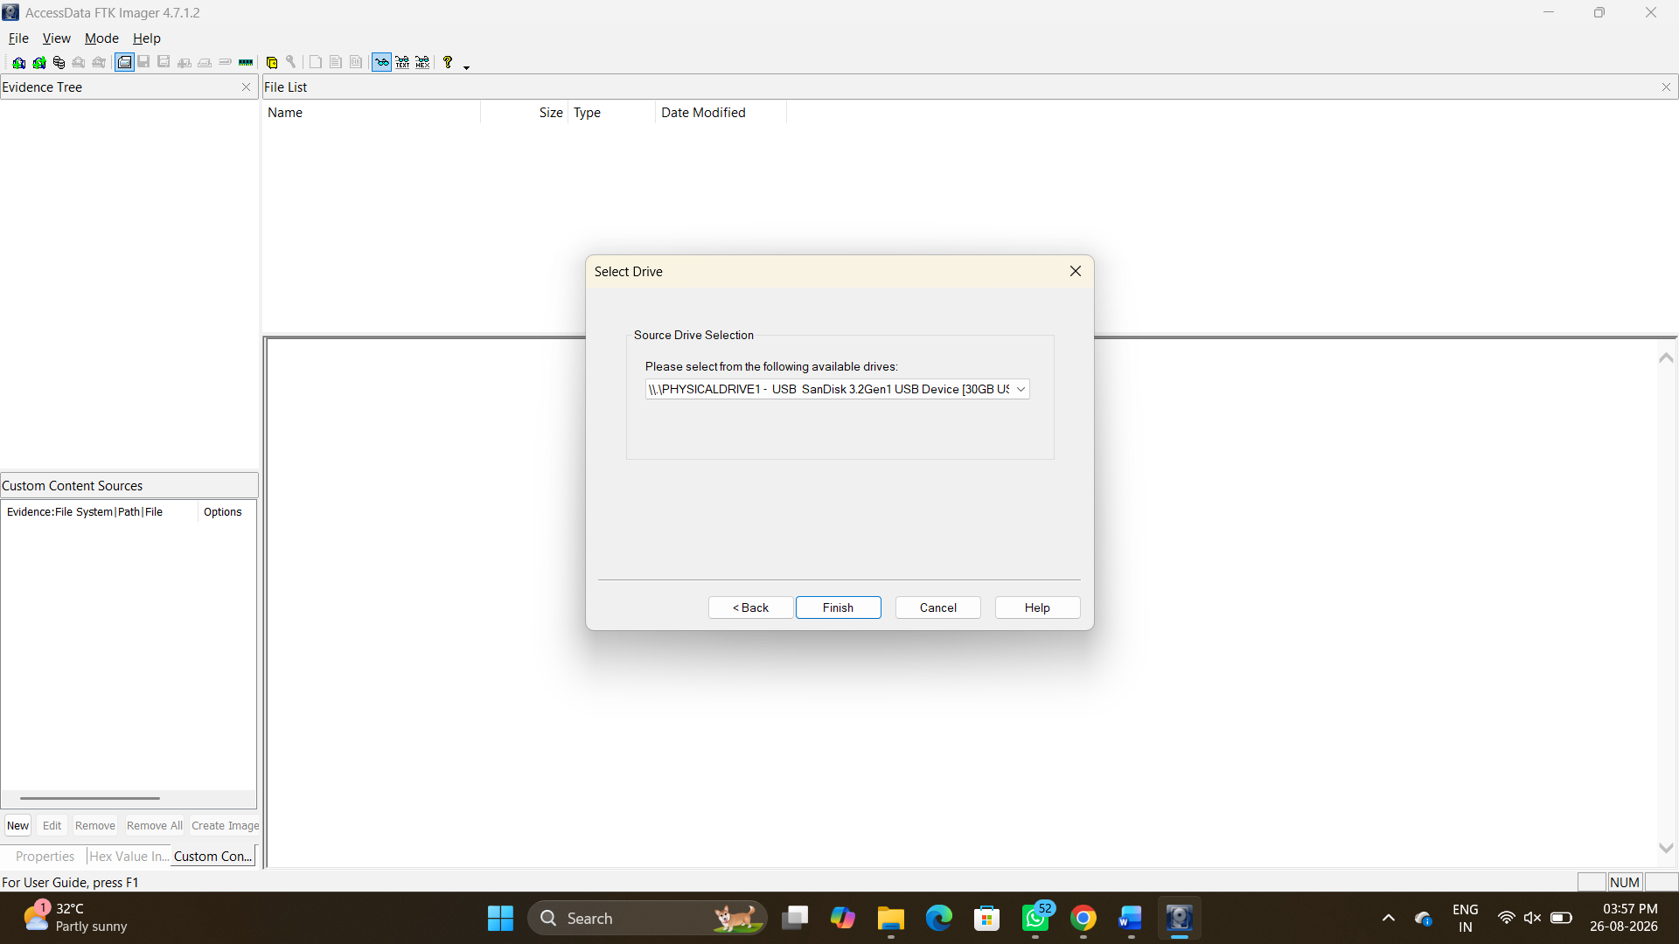
Figure 2: Selecting the target USB device for acquisition
Step 3: Choose the Image Type
Select Raw (dd) as the destination image type to create a pure bitstream copy.
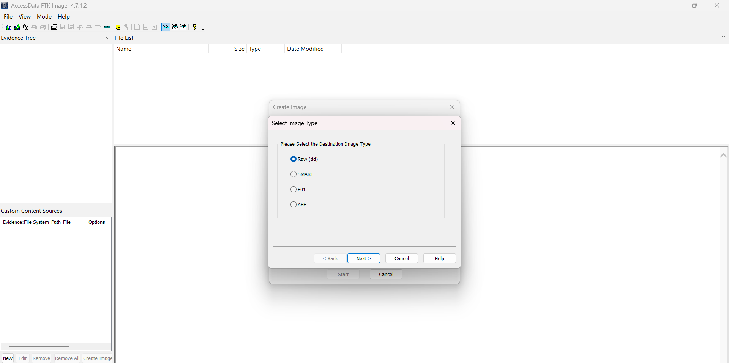
Figure 3: Configuring the destination image format to Raw (dd)
Step 4: Enter Evidence Item Information
Provide the standardized case details to maintain the chain of custody:
- Case Number: 01
- Evidence Number: 01
- Unique Description: Examine
- Examiner: Aasif Ahmed A
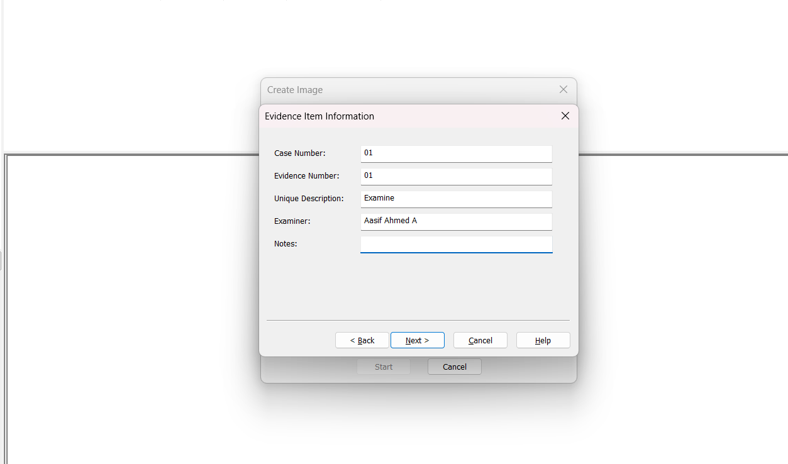
Figure 4: Entering the forensic case and examiner details
Step 5: Configure Image Destination
Set the destination folder to D:\ and the filename to Result. Set the Fragment Size to 20 MB and check Verify images after they are created.
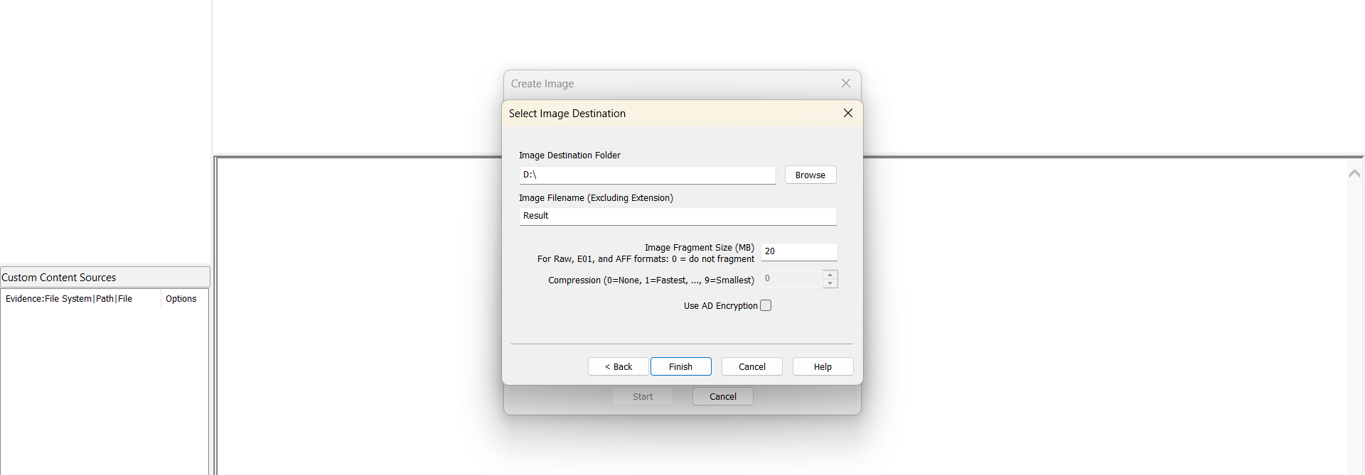
Figure 5: Setting the destination path, filename, and fragmentation size

Step 6: Monitor Acquisition Progress & Hash Verification
Click Start. Once complete, FTK Imager hashes the original drive and the newly created image. Review the Drive/Image Verify Results.
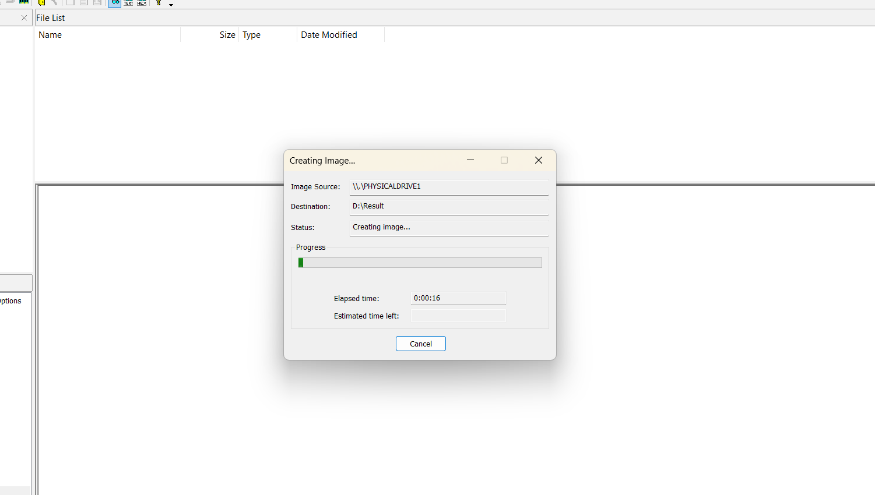
Figure 6: Disk imaging progress tracking
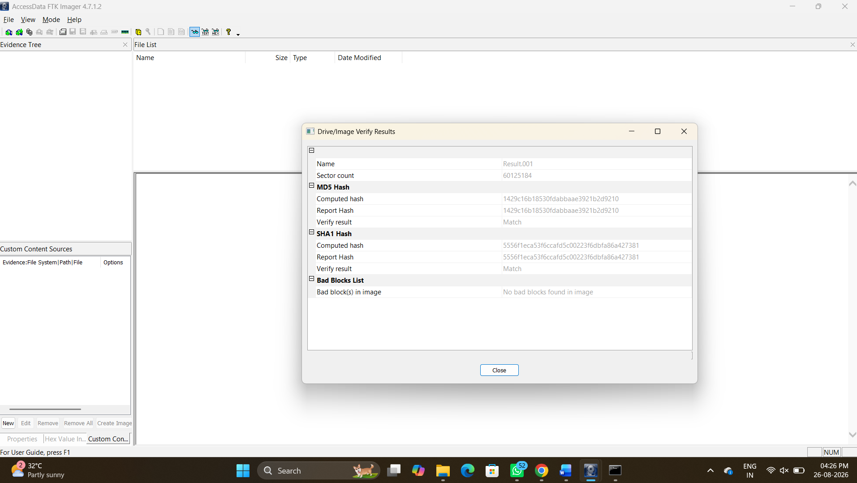
Figure 7: Successful verification of MD5 and SHA1 hashes
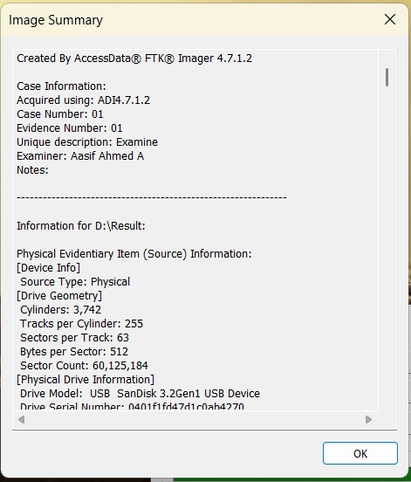
Figure 8: Image Summary detailing the physical device geometry
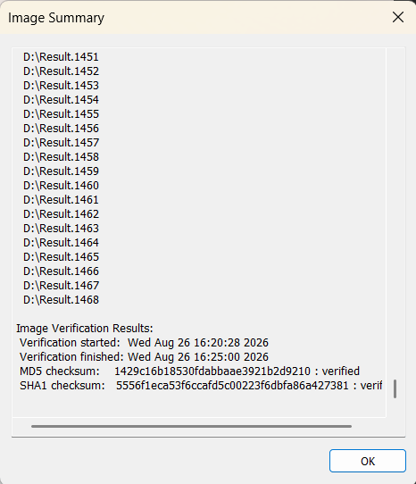
Figure 9: Image Summary detailing the hash verification results and segment list

Conclusion :
The digital evidence acquisition process was successfully completed using FTK Imager. A bit-by-bit Raw (dd) image of the target 16GB USB storage device was created while preserving the integrity of the original evidence. The evidence details and case information were properly recorded to maintain the chain of custody. The acquired image was successfully verified using MD5 and SHA1 hash values, confirming the integrity and authenticity of the forensic image. Thus, the experiment demonstrated the proper procedure for acquiring and verifying non-volatile digital evidence in a forensic investigation.

